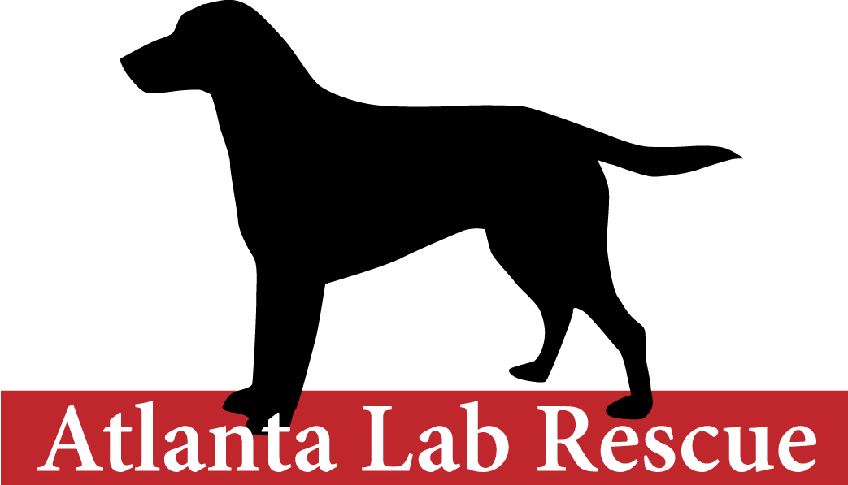
Atlanta Lab Rescue
P. O. Box 250206
Atlanta, Georgia 30325

Dear Applicant:

Thank you for inquiring about adopting a Labrador Retriever. If you can provide the special home a Labrador Retriever deserves, we will offer you a dog that will be a wonderful addition to your family.

The procedure for adopting a dog is as follows:

1. Please complete the application and MAIL to the address listed on the bottom of your application; FAX to 404-254-0423; EMAIL to info@atlantalabrescue.com

2. After your application has been received, our adoption coordinator will conduct a phone interview with you to discuss Atlanta Lab Retriever in general and specifically any rescue dogs that would be a good match for you. A home check from one of our volunteers is necessary to complete the process.

3. The minimum donation, at the time of adoption, for a Labrador Retriever is $350.00 for a dog up to 7 years of age. The minimum donation for a Labrador Retriever 7 years and older is $250.00.

4. We reserve the right to refuse an applicant if, in our opinion, the home situation is not compatible with the needs of a Lab. We require that the dog be maintained primarily as an indoor dog and cannot be chained or left unattended in a yard.

We have successfully placed hundreds of Labrador Retrievers in loving homes. All Atlanta Lab Rescue dogs have had a physical exam, are neutered or spayed, immunized, and heartworm tested. Most dogs come to us from homes where there has been a move, a divorce, allergies, or just not enough quality time to spend with the dog. Others come to us from shelters, or as strays.

Our organization is comprised of hard-working volunteers whose only reward is seeing these wonderful Labs placed in loving homes and given a second chance for a happy life.

Sincerely,
Atlanta Lab Rescue
Atlanta Lab Rescue
P. O. Box 250206
Atlanta, GA 30325-7907

Adoption Application Form

The answers you give on this application will help us find the best possible match between you and a dog that might be available through ALR.

Name:

Address:

City: State: Zip:

Home Phone: Work: E-Mail Address_________________

Best time to call: Occupation:

1. Personal references (Name & Address):

Relationship: Phone:

2. I live in a (circle one) house apartment condo mobile home other (describe)?

3. Do you own or rent your home?

If you rent, do you have your landlord’s permission to keep a dog?

Landlord’s Name: Phone:

4. How long at this address? If less than one year, previous address:

5. Do you have a fenced yard? Height and type:

6. If no fence, how will you handle the dog’s exercise and toilet duties?

7. Total number of people in your household: Adults Children (w/ ages)

8. Is anyone in your home allergic to dogs/dog hair?

9. Have you ever owned a dog? If yes, give details and history of each:

10. What other animals are in your household?

11. Your current veterinarians name, address and phone number:

12. Have you ever owned a rescue dog? What breed?

13. What type of Labrador Retriever or Lab would you prefer? ______

14. Is there an ALR dog that you are interested in? ________________________________________

15. Where will your dog spend the day? ______

16. How many hours (average) a day will the dog spend alone?

17. Where will your dog stay at night?

18. Will you enroll in obedience training? ______

19. Will you be willing to let a representative from ALR visit your home?

20. Where did you hear about Atlanta Lab Rescue?

All of the information I have given above or on the reverse side is true and complete. The dog will reside in my home as a pet. I will provide it with food, shelter, water, training, affection and medical care including heartworm preventative. If my application is approved, I understand that it is my responsibility to see and evaluate the dog for myself before agreeing to adopt it.

Applicant signature(s) Date

